**K2 Data Science -H1B Visa Petitions 2011 - 2016**

The H-1B is an employment-based, non-immigrant visa category for temporary foreign workers in the United States. For a foreign national to apply for H1-B visa, an US employer must offer a job and petition for H-1B visa with the US immigration department. This is the most common visa status applied for and held by international students once they complete college/ higher education (Masters, PhD) and work in a full-time position.

**Goals:**

I would like to find the

* top 5 states with the least denial rate.
* top 5 employers who have filed H1B for its employees
* top 5 job titles for which H1B was filed

In addition I would like to recommend the top 5 state - employer - title which has a higher scope for acceptance.

**Initial Data Cleaning Approach and Findings:**

I examined the H1B Visa Petitions data available on Kaggle. I did an initial data clean up and checked for missing values in the data set. Deleted the column “Unnamed 0” as it is just a numbering and reset the index. The columns which would be consideration are

CASE_STATUS: Status associated with the last significant event or decision. Valid values include “Certified,” “Certified-Withdrawn,” Denied,” and “Withdrawn”.

EMPLOYER_NAME: Name of employer submitting labor condition application.

JOB_TITLE: Title of the job

WORKSITE: City and State information of the foreign worker's intended area of employment

The WORKSITE column has city and state information in the same column. I used a python function to create a new column ‘STATE’ which contains only the state for which the petition has been filed. Examined ‘STATE’ to find that it has 53 unique states of which one is ‘NA’. Replaced ‘NA’ with Mariana Islands.

Top States with least denial rate:

Initially, plot the total filed petitions per state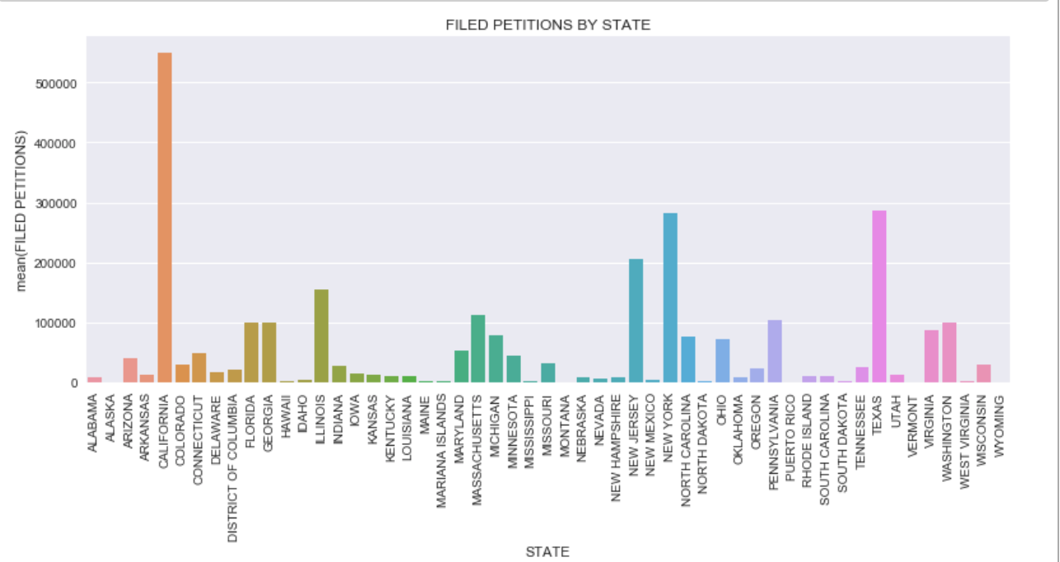

Fig 1: Filed Petitions per state

Observations:

California has the highest number of H1b applicants, followed by Texas, NewYork, New Jersey, Illinois.

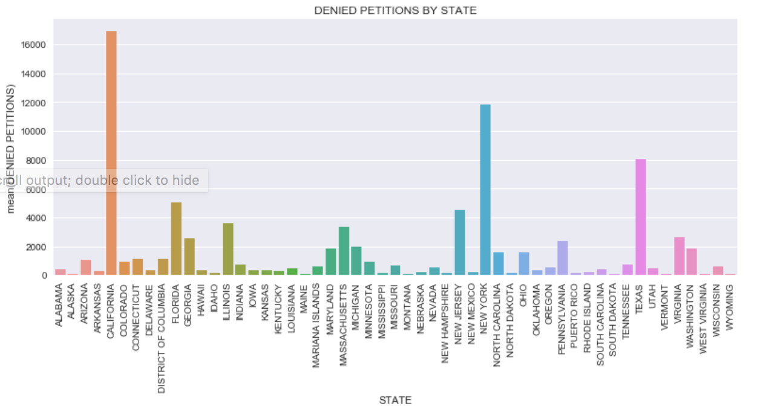Then I filtered denied petitions from the data set.

Fig 2: Denied petitions per state

Observation: It can be observed that California has the highest denied petitions.

Now I calculate the rate of denied petitions as follows

rate of denied petitions per state = denied petitions per state / total # of petitions applied per state. This gives us the denial rate of each state. The top 5 states with least denial rate are as follows.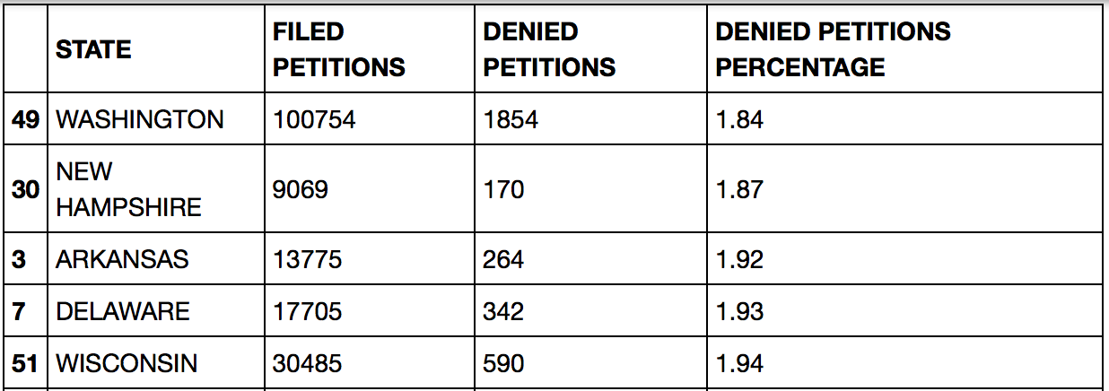

Top Employers:

Fig 3 illustrates the top 10 employers who have filed H1b applications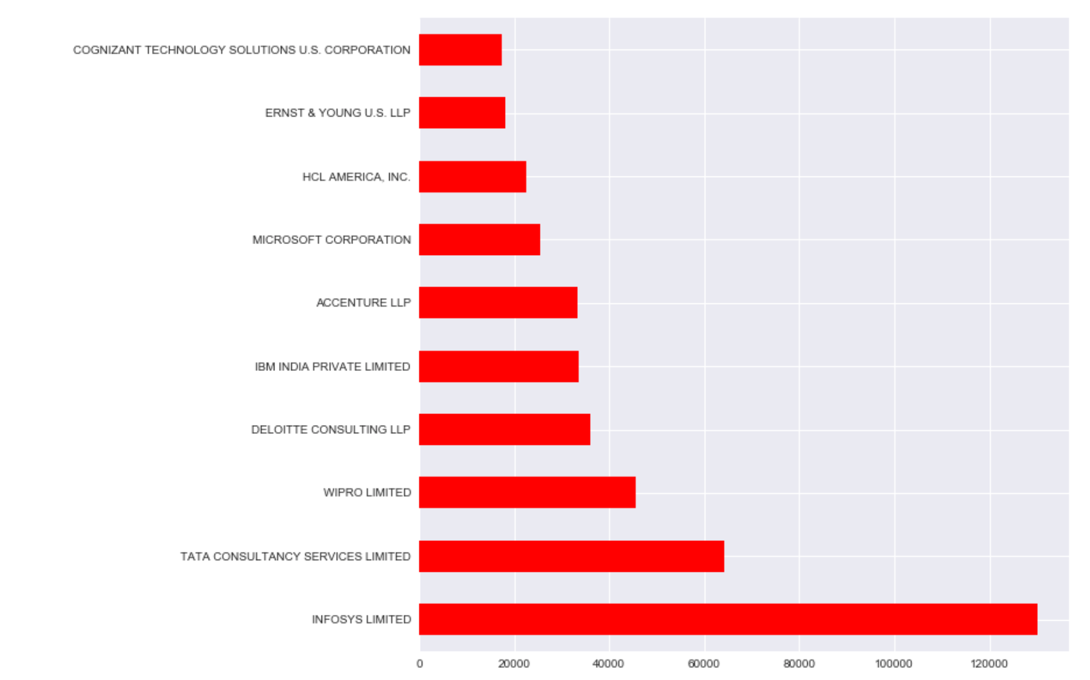

Fig 3: Top Employers who have filed H1B petitions

Observations:

* It can be observed that Infosys Limited has filed the most number of applications. It has filed more than twice the number of applications than the second second top employer i.e TCS
* The top 5 employers happen to be Indian Consulting firms.
* Most of the the top 10 employers are software tech firms except for EY.

Top Job Titles:

Fig 4 illustrates the top 10 job titles for which H1b has been applied for.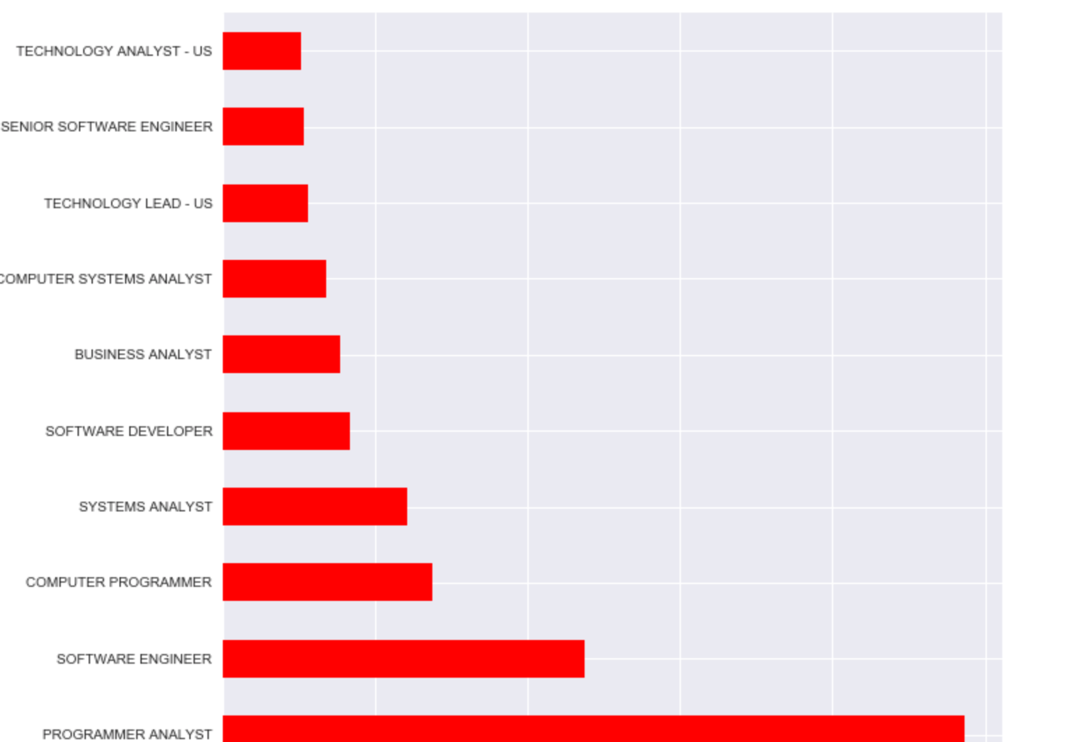

Fig 4: Top Job Titles for which H1b was applied

Observations:

* Most of the top 10 job titles are computer related tech jobs. To recap, the top companies which filed the H1b also are software/tech companies.
* Programmer Analyst is the Job title for which most H1b applications were filed. This title requires a very generic skill set when compared with titles such as “Machine Learning engineer”, “Data scientist” etc.

**Final Recommendations:**

Now, I consider only the certified applications for the states with least denial rate and check the top employer and top job title in that state.

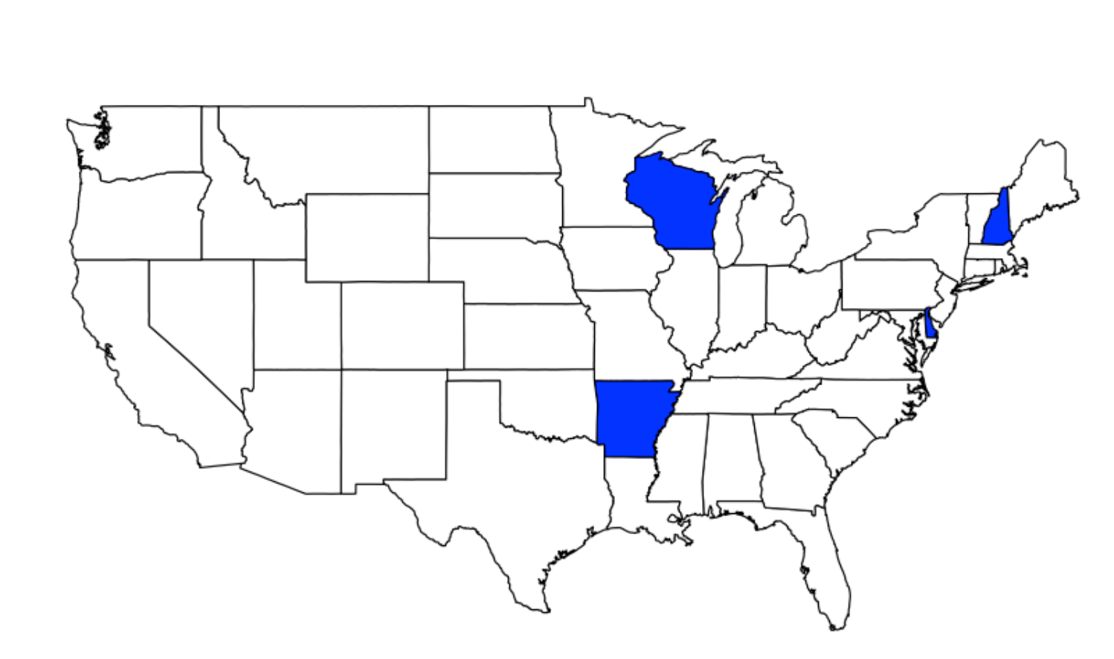

|  |  |  |
| --- | --- | --- |
| State | Employer | Job Title |
| Washington | Microsoft Corp | Software Development Engineer |
| New Hampshire | Infosys Ltd | Technology Lead - US |
| Arkansas | Infosys Ltd | Technology Lead - US |
| Delaware | Tata Consultancy Services Limited | Computer SystemsEngineer |
| Wisconsin | Infosys Ltd | Technology Lead - US |

Table : Top 5 states with the best employers and recommended Job Titles

Observations:

* Though the most number of applications have been filed for Programmer Analyst, the job title which has been certified by those respective companies is not programmer analyst.
* The top employers are Indian consulting firms except Microsoft
* All the recommended jobs are tech/computer related jobs.

**Further Analysis:**

I found that that the average wage for denied applications is $5096 less than certified applications. I would like to explore the wages offered for the roles and if it has any relationship to the cost of living in the state in which it was offered